TEACHER PROFESSIONAL DEVELOPMENT

STUDENT - CENTERED LEARNING IN MATHEMATICS WHAT DOES IT LOOK LIKE?
Four-Hour Workshop for Math Educators

Workshop Leader: Dr. Cathy S. Liebars, Associate Chair of the Mathematics and Statistics Department and the Mathematics Education Coordinator at The College of New Jersey
This workshop will review concepts of student - centered learning at the middle school and high school levels. Problem-based lessons at these grade levels will be discussed and resources will be provided. New Jersey Learning Standards calls for teachers to use instructional methods so that students use the Standards for Mathematical Practice in whatever content they are learning. Student-centered learning methods allow for and, in fact require these practices (problem solving, reasoning, explaining, modeling, etc.).

The Learning Outcomes for participants:

Dr. Cathy S. Liebars

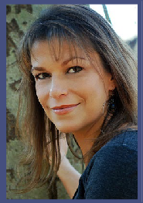
- Use student-centered methods in their mathematics classroom.
- Write a problem-based lesson plan in mathematics.
- Find resources for creating problem-based lessons.
- Adapt lessons to make them more student-centered.

Workshop Information
Date and Time: Friday March 22, 2019 10am - 3pm Location: The College of New Jersey Ewing, NJ
Certificate of Completion & Workshop Materials Provided Fee: $175.00
Online Registration at: https://goo.gl/WEuTaj
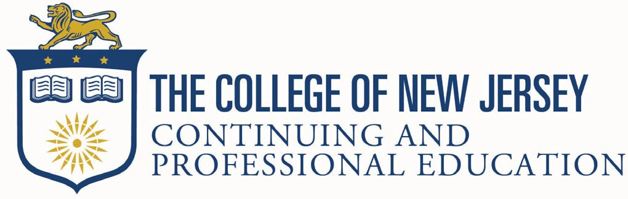
Dr. Liebars teaches courses for pre-service teachers at all levels in the content area of mathematics. Dr. Liebars has presented workshops in several school districts in New Jersey on a variety of topics. She has worked with middle grades and elementary teachers, assisting in their implementation of reform-based mathematics programs like the Connected Math Program (CMP) and TERC Investigations in Number, Data, and Space. She is currently co-director of the Woodrow Wilson Teaching Fellowship induction grant at TCNJ. Dr. Liebars is a Past-President of the New Jersey Association of Mathematics Teacher Educators (NJAMTE), currently serves on their Executive Board, and is former chair of the New Jersey section of the Mathematical Association of America.

QUESTIONS?
George Hefelle • 609.771.2540 •aspire@tcnj.edu • cpe.tcnj.edu/pd-nj-educators/

